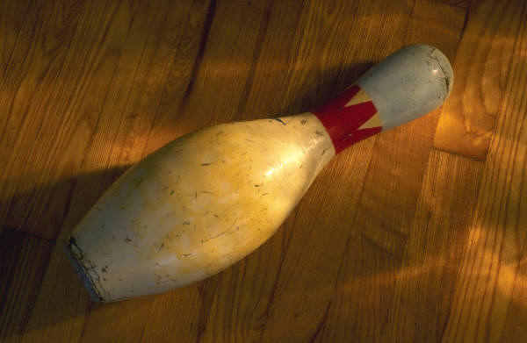

CPC Bowling for Everyone
Sign up Sheet

Name Number of Paid Bowlers

Graham 5
Hardie 4
Cheng 5
Newlands 2
Shirley 2
Charlie Z. 1
Dan Deacon 1
Catherine C. 1



CPC Bowling for Everyone

Date: Saturday, January 15th
Time: 4:00 to 7:00 pm or 5:00 to 7:00 pm (time to confirmed)
Place: Amity Bowling Lanes in the Westville area
of New Haven
Price per person: $6 - $8 (includes shoe rental)
We would like to reserve 10 lanes which would accommodate 60 bowlers, reduce prices and allow us to bring in our own food.
PLEASE see sign up on foyer table or email Lisa Graham at lisahgraham@comcast.net ASAP.

